**D.K.T.E. Society’s Textile and Engineering Institute, Ichalkaranji.**

**(An Autonomous Institute, Affiliated to Shivaji University, Kolhapur)**

**Accredited with ‘A+’ Grade by NAAC**

Department of Computer Science & Engineering

2023-2024



the MINI PROJECT srs and design document on

ONLINE MARKET PORTAL FOR FARMERS

**Under The Guidance Of**

**Mrs.P.S.More**

**DEVELOPED BY:**

1. Hajare Arya Sanjay 21UCS030
2. Kesare Ruturaj Sadashiv 21UCS042
3. Kesarwani Aishwarya Anil 21UCS043
4. Khandekar Ajay Sanjay 21UCSO45
5. Khane Sanika Devendra 21UCS046

**D.K.T.E. Society’s Textile and Engineering Institute, Ichalkaranji.**

**(An Autonomous Institute, Affiliated to Shivaji University, Kolhapur)**

Department of Computer Science & Engineering

INTRODUCTION

Welcome to something really exciting – our awesome project called the "FarmerFirst Market Portal." You know, farmers are like the superheroes of our economy, but sometimes they don't get the fair deal they totally deserve because of middlemen and those big buyers. So, we put on our thinking caps and decided it's time to make a change!

Picture this: farmers work super hard, but the way things are set up isn't always fair to them. Those middlemen and big buyers mostly care about making money, and that often means farmers don't get a fair price for what they grow. But guess what? Our project is like a Immortality for farmers, giving them a cool way to sell their stuff directly to the people who want it.

No more complicated stuff! Our "FarmerFirst Market Portal" is like magic – it decreases the marginal profit of middlemen and makes sure farmers get a good deal for the awesome stuff they grow. It's not just a fix; it's a chance for farmers to be in charge, and for all of us to be part of making farming way fairer.

So, get ready for a journey where technology meets farming, making it super easy for farmers to sell their fantastic goods. Let's all jump on board and be part of this awesome change, making sure farmers get the fair share they totally, absolutely deserve. Buckle up for a revolution in the fields!

PROBLEM STATEMENT

Our project aims to address the challenge of creating an "FarmerFirst Market Portal." providing a platform that enables farmers to sell their produce conveniently from the comfort of their homes.

PROBLEM DESCRIPTION

Our project tackles a big problem in farming. Currently, farmers face challenges selling their produce because middlemen and big buyers often treat them unfairly. Our aim is to create an "FarmerFirst Market Portal." to eliminate this issue.

Farmers, crucial to our economy, often end up with less money due to middlemen and big buyers seeking maximum profit for themselves. This not only hurts the farmers but also poses challenges for small businesses in farming.

Our project seeks to address this problem by establishing an online marketplace where farmers can sell their products directly to consumers. No middlemen, no big buyers setting unfair prices. This way, farmers can sell their produce at prices that are fair and based on market demand.

The core idea is to make things simple and fair. With our "FarmerFirst Market Portal" we empower farmers to have more control over their businesses. They can engage directly with consumers, negotiate fair prices, and ensure a mutually beneficial transaction.

TECH-Stack to be used :

1.Front-End : HTML , CSS , ReactJs, Javascript

2.Back-End : ExpressJs , NodeJs

3.DataBase : MongoDB

4.Version Control : Git , GitHub

5.IDE : VSCode

METHODOLOGY

Activity Diagram:

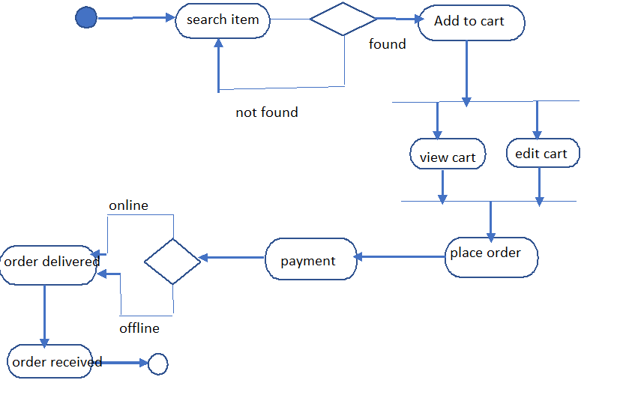

**Level 0 DFD**

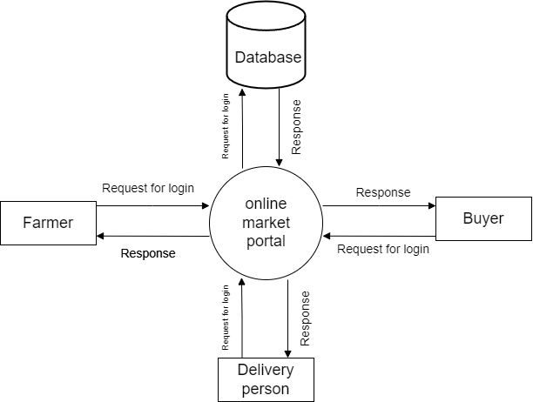

**Level 1 DFD**

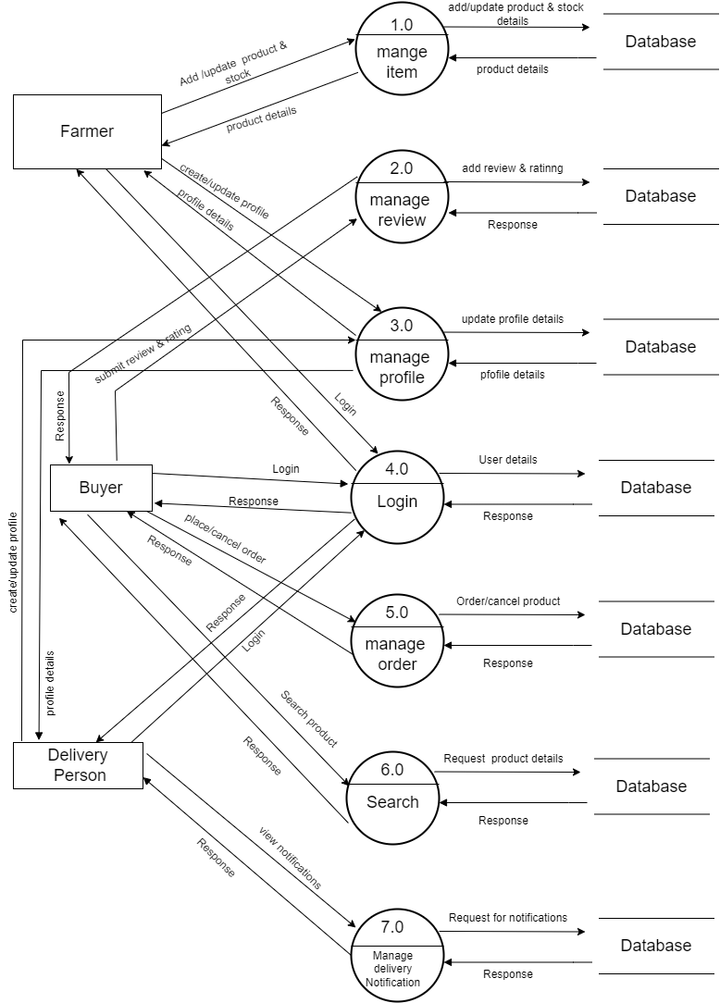

Activity Diagram:

